BARROW & FURNESS CONSERVATIVE ASSOCIATION MEMBERSHIP FORM

Your personal details Please add/amend as necessary
NAME AND ADDRESS
…………………………………………………………………………………………………………………………………………………………………………………………………………………………………………………………………………

Home no:
Mobile no:
Email:
Date of birth (if under 23):

To renew your Membership online, please visit our website at www.barrowandfurnessconservatives.org.uk/membership or scan the QR code above. More info? Telephone 07593 539 966
Your payment details: Cheque
£5 (YC -22 or under) £25 (recommended minimum) £50 £75 £100 Other £ ……………
Please make cheques payable to Barrow & Furness Conservatives

Your payment details: Standing Order 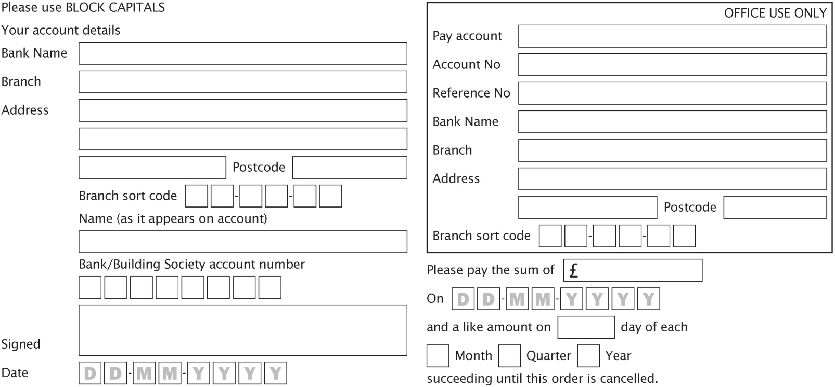
NOTE: When setting up a Standing Order, please ensure the date of your initial payment is at least one month after you post this letter to allow the bank time to process and set up the Standing Order.

How you can help us?
I can display a poster at election time I would like to get involved in local campaigns
I would like a postal vote I would like to stand for Council
I can help with data inputting on the computer
Membership recruitment - I think I might know of a potential new member, please send a membership recruitment form to:
NAME…………………………………………………………………………………………
Please return your form to:
Barrow & Furness Conservatives,
93 Market Street, Dalton in Furness, LA15 8DL

ADDRESS ………………………………………………………………………………………

………………………………………………………………………………………………

You must be on the electoral register in the UK excluding the Channel Islands and the Isle of Man in order to make a donation of more than £200.
*By giving us your email address and/or mobile number, you are agreeing to receive communications and information from us by email or SMS. If you are registered for the Telephone Preference Service, by giving us your telephone number you are giving us permission to ignore this and occasionally call you.
** In order to qualify as a member with full voting rights, the minimum subscription is £25 This does not apply if you are 22 or under.
Promoted and printed by Ben Shirley on behalf of Barrow & Furness Conservative Association, both at 93 Market St, Dalton in Furness, LA15 8DL.

